TABLE OF CONTENTS

T1. Bidder Information 3
T2. Description of the Work Plan 9
a) Execution Summary 9
b) Organization / Key Personnel 10
c) Mobilization and Manpower 13
d) Project Management 13
e) Project Control 15
f) Basic and Detail Engineering 25
g) Procurement, Subcontracts and Construction 32
h) Training, Commissioning, Start‐up and Handover 32
i) Health, Safety and Environmental 32
j) Quality Control and Quality Assurance 34
T3. Technical Data 35
T4. Bidder’s Schedule 36
4.1. Table G-1 - General Information 36
4.2. Table G-2 – Milestones 36
4.3. Table G-3 - Contractor Key Milestones (Clauses 8.2 & 8.7 of Conditions of Contract) 36
T5. Organization / Key Personnel 37
T6. Proposed Subcontractors and Suppliers 38
6.1. Construction Contractor 38
6.2. Supplier 38
T7. Bidder Experience 39
7.1. Similar Experience over the last 5 years (Soft Work) 39
7.2. Petrochemical EPC Experience over the past 7 years (EPC) 40
T8. Technical Alternatives 42
T9. Acceptance of Conditions of Contract 43
T10. Local Content and Saudization 44
T11. Safety Record 45
T12. Quality Assurance 46
12.1. QA/QC Plan 46
12.2. Quality Management Manual 46
12.3. ISO 9001 Certificate 46
12.4. Quality Organization Chart 46
T13. Summary of Bidders Manhours 47
T14. Unpriced Estimated Construction Quantities 48
T15. Assumptions and Exclusions 49
Appendices 51
Appendix 1 – FEED Schedule (Preliminary)
Appendix 2 – QA/QC Plan
Appendix 3 – Quality Management Manual
Appendix 4 – Quality Procedure List
Appendix 5 – ISO 9001 Certificate
Appendix 6 – CVs of Key Personnel
Appendix 7 – Pre-Bid Clarifications for Technical and Commercial

- Bidder Information
- Name of the Bidder: | DL E&C Co., Ltd.
- Type of Entity: | Joint Stock Company
- Address: | One Grove A-Dong, 165 Gonghang-daero, Gangseo-Gu, Seoul Republic of Korea (07800)
- Telephone No.: | (Tel) 82-2-369-5611 (Fax) 82-2-2011-8039
- E‐mail: | yongkim@dlenc.co.kr
- Established When and Where: | October 10, 1939  Seoul, Republic of Korea
- The Bidders Bank(s): | Woori Bank (Magok One-Grove C-Dong Building)  A/C No.: 323-001094-41-294  Swift Code: HVBKKRSEXXX
- Registered Capital  (Quote in SR Equivalent): | 229.30 billion won (552.6 million SAR)
- Principal Officers of the Bidder (Name & Titles): | Mr. Seong Yeol Kim / Project Director  Mr. Yong Kim / Project Manager

- Licenses to Perform Work (issuing authority, date & validity): | Certification of International Contractor (International Contractors  Association of Korea, Issued on February 2, 2014, Validity indefinite)    
- Copy of Bidder’s Commercial Registration: | 
C.R. No: 676-87-01904
Issue Date: 21/12/11
Expiry Date: Valid indefinite
- Copy of Zakat and Income Tax Certificate: | Zakat File No.: 3004428154(TIN) / 1117257451(Certificate No.)  Issue Date: 5/5/2026  Expiry Date: 30/04/2027    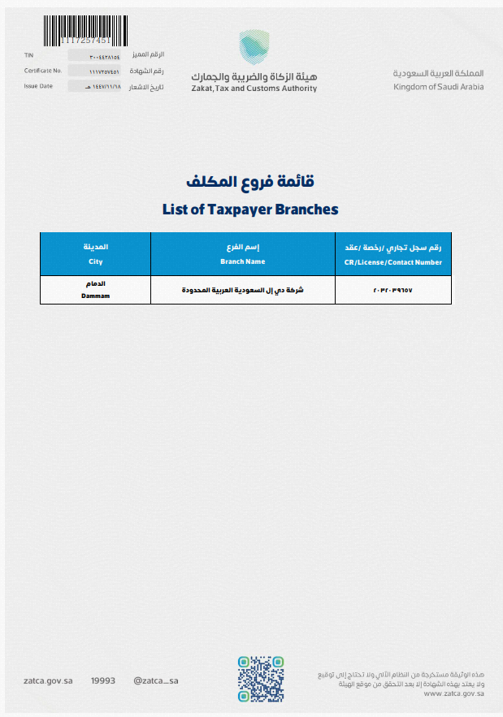

THIS APPENDIX FORMS PART OF THE BID
SUBMITTED BY
WORKS: EPC CONTRACT FOR MM Cluster PROJECT, KSA
RFP NO.: CPP-ITB-PD&E-26-101 |     DATE: ………………….……28 Oct.2026……………………….
SIGNATORY OF BIDDER | …………………Yong Kim………………………..………..………….

- Description of the Work Plan

a) Execution Summary
Saudi Arabian Mining Company, Ma’aden (hereinafter referred to as the “Employer”) intends to build a gold process plant with an annual throughput capacity of 4 MTPA scalable to 8 MTPA at Mansourah and Massarah in the Central Arabian Gold Region (CAGR), Kingdom of Saudi Arabia (hereinafter referred to as the “Project”). As a priority open pit gold development within the Employer’s acceleration portfolio, the Employer is seeking proposals from suitably qualified bidders.

The Project will be executed in two phases: Phase 1 involves the development of FEED and the preparation of a transparent and fully substantiated Open Book Estimate (OBE) based on the developed engineering, while Phase 2 consists of the full EPC execution under a Convertible Lump Sum Turnkey (CLSTK) contract. The award of Phase 2 is subject to the Employer’s acceptance of the OBE developed in Phase 1.

DL E&C Co., Ltd. (hereinafter referred to as the “Bidder”), a leading international engineering and construction company based in Korea, possesses extensive experience in project development, basic engineering, FEED, and EPC execution across global markets.
In particular, the Bidder has successfully completed the Ammonia II and III projects at Ras Al Khair, which were awarded by the Employer.

Drawing on its extensive experience, accumulated know-how, and ample resources, the Bidder is prepared to provide transparent services and offer a competitive and attractive position compared to other options the Employer may consider. Moreover, the Bidder will integrate and share the knowledge gained from years of industry operation to achieve a cost-effective, on-time, safe, and high-quality Project. Building on a proven partnership with various companies from various projects, the Bidder combines extensive process design expertise and OEM coordination capability.
Transparency and one-team spirit are central to the Bidder’s way of working and have been key success factors in its collaboration with the Employer to date. By maintaining open communication, shared accountability, and a unified project mindset, the Employer and the Bidder together achieve faster decisions, smoother coordination, and consistent quality across all deliverables.

The execution approach empathizes;
- Commitment to Quality: The Bidder will have a stringent quality management framework conforming to international standards and the Employer’s requirements. Comprehensive design reviews, multi-disciplinary coordination, and systematic verification processes will ensure engineering integrity, operability, and maintainability throughout the Project scope.
- Schedule Reliability: A detailed and realistic execution schedule has been structured to align with the Employer’s overall project milestones. Through early engagement of the stakeholders, front-end loading of critical activities, and proactive risk management, potential schedule deviations will be minimized. This approach ensures timely delivery of all deliverables and readiness for immediate roll-over to Phase 2 (CEPC Lump Sum Turnkey) execution.
- Cost Definition and Transparency: The Bidder will execute OBE(Open Book Estimate) derived from comprehensive quantity take-offs, updated market data, and validated vendor quotations. This well-defined cost basis will provide the Employer with a transparent and defendable estimate for final investment decision and EPC contracting.
- Seamless Roll-over to Phase 2 - CEPC Lump Sum Turnkey: By integrating disciplined project management practices, mature engineering definition, and consistent cost control methodologies, the engineering deliverables will form a complete and reliable foundation for EPC execution. The Bidder team’s ultimate aim is not only to finalize OBE within the planned schedule and budget, but also to facilitate a smooth, efficient, and successful roll-over to the EPC phase - ensuring continuity, cost efficiency, and excellence in execution for the Project.

b) Organization / Key Personnel
Organization
The Bidder’s corporate organization chart is presented in Figure 2.1, and project organization chart is shown in Figure 2.2. The blue arrows indicate coordination and information exchange between the Project Team and Home Office Support.
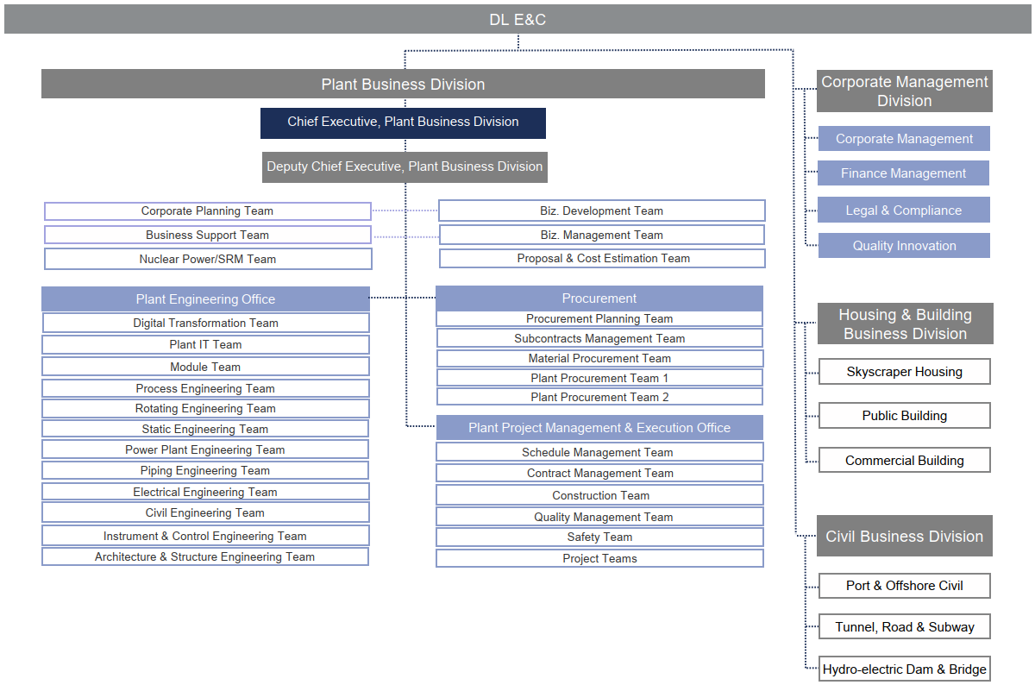
- Corporate Organization Chart
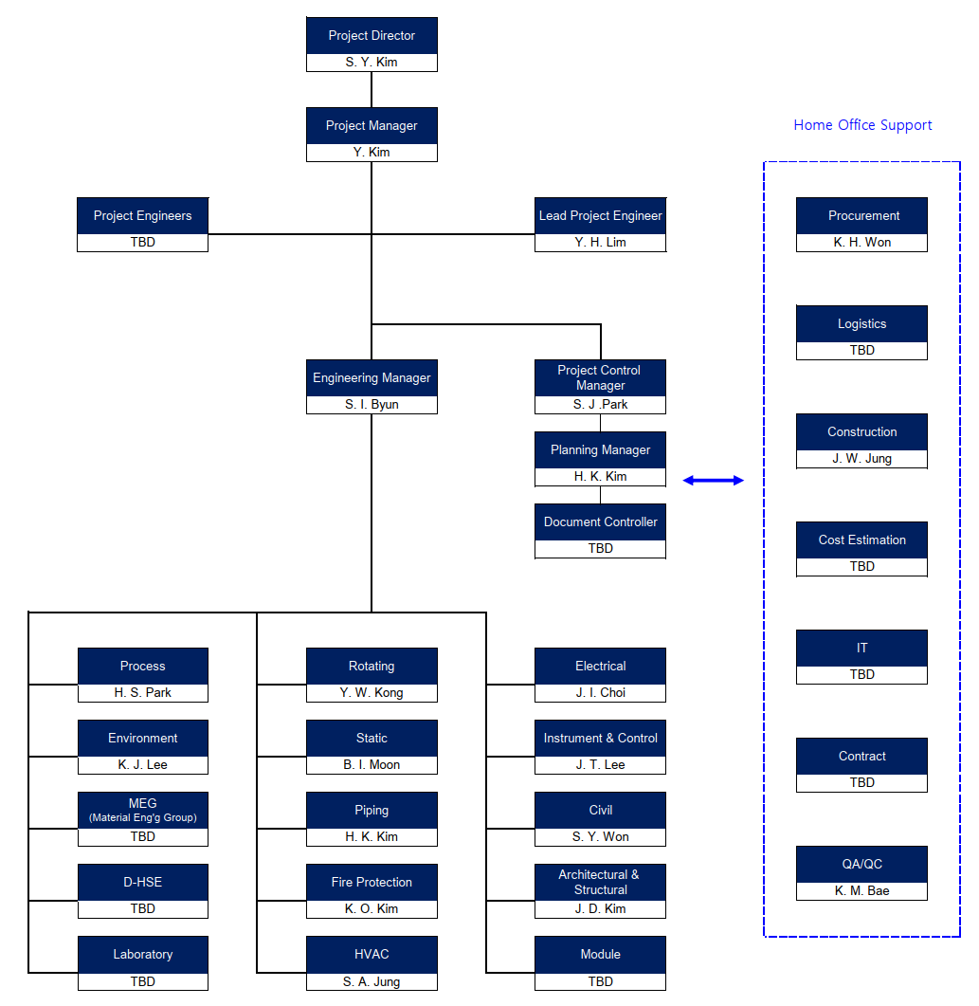
- Organization Chart

Key Personnel
The Bidder’s key personnel are listed in the table below. Please note that the proposed key personnel may be subject to change during the execution of the Project.
The CVs of the key personnel are provided in Appendix 6.

No. | Position | Main | Alternative | Remark
01 | Project Director | Seong-Yeol Kim | -
02 | Project Manager | Yong Kim | Dong-Ryul Paek
03 | Engineering Manager | Sung-Il Byun | Bong-Kyun Kim
04 | Lead Project Engineer | Young-Hoon Lim | Jun-Ho Kim
05 | Lead Process Engineers | Hyun-Sam Park | Sun-Kil Kim
06 | Lead Rotating Equipment Engineer | Young-Wook Kong | Ji-Sang Kang
07 | Lead Static Equipment Engineer | Byeong-Il Moon | Seul-Gi Kim
08 | Lead Piping Engineer | Hong-Kyung Kim | Il-Ho Hwang
09 | Lead Fire Protection Engineer | Kyu-Oh Kim | Eun-Ji Kim
10 | Lead HVAC Engineer | Sun-A Jung | Jae-Woo Nam
11 | Lead Electrical Engineer | Jun-Il Choi | Jung-Jae Choi
12 | Lead Instrument & Control Engineer | Jung-Tae Lee | Seung-Hoi Kim
13 | Lead Civil Engineer | Seong-Yeon Won | Sang-Jin Hong
14 | Lead Arch. and Str. Engineer | Jae-Dong Kim | Won-Suk Lee
15 | Lead Environmental Engineer | Kwang-Je Lee | Hong-Jin Chae
16 | Project Control Manager | Seong-Jun Park | Young-Su Kim
17 | Planning Manager | Hyung-Kuk Kim | Kwang-Uk Seon
18 | Procurement Manager | Keon-Hee Won | Kyung-Ho Kim
19 | Construction Manager | Jin-Won Jung | Yong-Kil Jeong
20 | QA/QC Manager | Kyung-Min Bae | Hyung-Jin Kim

c) Mobilization and Manpower
Please refer to the Bidder’s preliminary manpower mobilization plan as presented below.

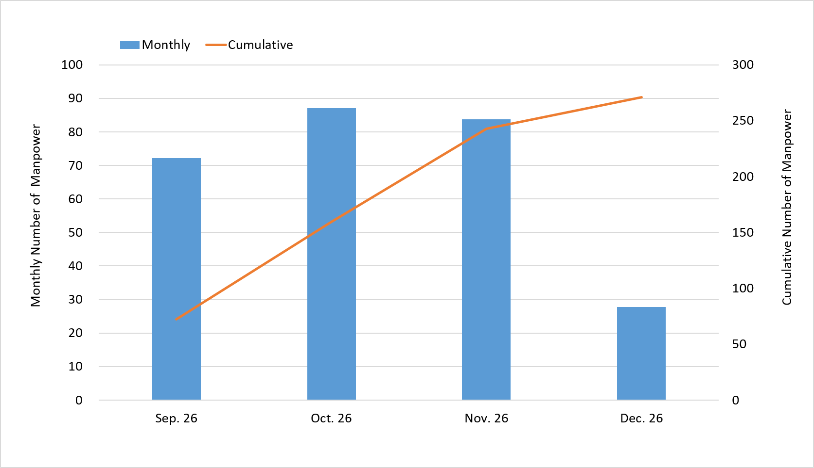
- Manpower Mobilization Plan (Preliminary)

d) Project Management
The Project will be executed under a structured and integrated Project Management framework that aligns with recognized industry best practices and the Employer’s requirements. The objective is to ensure that scope, schedule, cost, quality, and risk are effectively controlled, while establishing a solid basis for a seamless roll-over into the Phase 2.

- Engagement of the Project Management Team staffed by experienced personnel
At the commencement of the Project, a dedicated Project Management Team (PMT) with experienced personnel will be established, led by a qualified Project Manager with clear authority and responsibility for the Project. The PMT will include functional leads for engineering, project controls, procurement, quality, and interface management, each with defined roles and reporting lines documented in an organizational chart. Formal governance will be maintained through the regular progress reviews, and stage-gate approvals at key milestones.

- Optimization of Schedule
A baseline schedule will be developed at the outset, reflecting the full scope, key interfaces, and the Employer’s milestones, structured at an appropriate level of detail for effective monitoring. The schedule will incorporate critical engineering activities, risk response actions, and the Employer’s milestone. Progress will be controlled through periodic schedule updates, variance analysis, critical-path monitoring, and forecasting of completion dates, enabling timely implementation of recovery or acceleration measures where necessary.

- Early Site Engagement and Engineering Set-up
Key discipline engineers will be mobilized to the site for one (1) week during the early stage of Phase 1 to conduct site surveys, verify existing conditions and interfaces, and establish the engineering design basis and set-up.
This early site engagement will enhance the Bidder’s understanding of the existing MMGP facilities, facilitate effective implementation of the re-use design strategy, identify potential interfaces and constraints at an early stage, and minimize subsequent design changes and schedule impacts, thereby supporting the accelerated Phase 1 schedule and seamless transition into Phase 2 EPC execution.

- Risk, Interface and Stakeholder Management
Project risks will be systematically identified, assessed, and treated through a living risk register, with mitigation and contingency measures integrated into the schedule and cost plans. Interfaces between disciplines, packages, licensors, and third parties will be managed through clearly defined interface points, responsibility matrices, and coordination meetings to prevent gaps or overlaps in scope. Stakeholder expectations, including those of the Employer and OEM, will be effectively addressed through structured communication, timely reporting, and early alignment on key technical and execution decisions.

- Seamless Roll-over to EPC
Project performance will be continuously monitored and communicated through standardized regular reports, providing clear and transparent visibility of progress, schedule, cost, and key issues to the Employer.

Considering the accelerated six (6) month duration of Phase 1, the engineering activities will be focused on the minimum deliverables required to support the OBE, key technical decisions, and readiness for Phase 2 EPC execution. Rather than developing a complete set of new engineering deliverables during Phase 1, the Bidder will maximize the use of the existing MMGP as-built engineering documentation, designs, MTOs, vendor data, and other available information provided by the Employer.

A re-use design strategy will be applied wherever practicable, whereby the existing MMGP design will be reviewed, validated, and adapted to the Project-specific requirements. Engineering developed during Phase 1 will be progressively carried forward and further developed during Phase 2, thereby minimizing duplicated engineering efforts and supporting a seamless transition into EPC execution.

Particular emphasis will be placed on the early alignment of key technical decisions, constructability considerations, procurement strategies, long-lead items, and major interfaces during Phase 1. This approach will enable the Bidder to identify and address critical issues early while preparing an execution-ready foundation for Phase 2.
To further facilitate a seamless roll-over into Phase 2, the Bidder will discuss and align with the Employer during Phase 1 on practical arrangements to enable early commencement of topography survey, geotechnical investigation and temporary office work. Early execution of these activities will support the timely availability of site data, facilitate early issuance of construction drawings, and enable continuous progression of subsequent construction activities without unnecessary interruption between Phase 1 and Phase 2.

Through the effective utilization of the existing MMGP design, focused engineering development, and proactive project controls, risk, and interface management, the Bidder will establish a practical and efficient foundation for the seamless roll-over from Phase 1 into Phase 2 EPC execution, while minimizing schedule impact and unnecessary re-engineering.

e) Project Control
The Bidder will implement a structured approach to meet the Project control requirements during the execution stage. The Bidder’s Project Control Group will operate as an integrated group under the leadership of the Project Controls Manager throughout Phase 1, providing accurate setup, regular updates, and reliable trend analysis to support successful project execution.
Established engineering, procurement, and construction procedures will be applied to develop baseline Phase 1 progress measurements, schedule, and staffing plans. These baselines will be used to monitor performance, report status, and provide forecasting and trend analysis.
This project controls plan outlines the implementation strategy, processes, tools, and information that will be applied by the Bidder to effectively manage and control the Project during Phase 1, including those to be communicated to the Employer in relation to the following Project Controls elements:

- Control of Projects Organization
- Staff Planning and Forecasting
- Planning Management
- Progress Measurement
- Cost Control
- Estimating (including OBE)
- Document Control
- Change Management
- Risk Management
- Reporting
- Forecasting

For successful completion of the Project, “Monitoring and Control” of schedule on regular basis is essential. This requires all personnel associated with the Project to participate in this program as a unified team. The Project Control Group assigned to the project will be responsible for determining the project control strategy and overall project control.

Planning
- Schedule Baseline
A Phase 1 schedule baseline will be established for the Project. The Project will be continuously monitored against this baseline, which comprises the approved scope of work, work breakdown structure (WBS), schedule, and progress measurement methodology, providing a reliable basis for effective project control.
Baseline revisions will be strictly managed through the change control process. Only approved changes to the scope of work may result in updates to the baseline. At any given time, the current project budget will be defined as the approved baseline estimate plus all authorized scope changes.
The Phase 1 schedule baseline may be adjusted in response to changes in scope or execution strategy, subject to mutual agreement between the Employer and the Bidder. However, the original baseline will be maintained for reference unless formal re-baselining of the Project is approved.
Approved project baselines may also be revised at predefined project milestones or when significant changes in scope or execution approach justify such revisions, subject to the Employer’s approval.

- Work Breakdown Structure (WBS)
A Project Work Breakdown Structure (WBS) will be established to divide the overall Project scope into discrete, manageable work elements aligned with the defined project deliverables. The WBS incorporates a logical coding structure that enables effective tracking of progress, cost, man-hours, and schedule.
The level of detail of the WBS will be appropriately defined to support efficient project execution, performance monitoring, and the collection of relevant historical data for future references.
Phase 1 Work Breakdown Structure:
- Level 1 Contract
- Level 2 Package
- Level 3 Phase
- Level 4 Discipline/Craft
- Level 5 Work Package

- Schedule Control
Schedule Objectives and Roles
Planning and scheduling have a major impact on Project cost. When the Employer achieves the goal of putting the new facilities into operation, the value of being one day ahead of or behind schedule can result in substantial additional or lost profit per day. All personnel involved in the development and analysis of the Bidder’s schedules will keep this economic perspective clearly in mind.
In Phase 1, the Project Controls Group has responsibility for establishing and maintaining the Phase 1 schedule baseline. In addition, they will provide functional leadership in Project planning efforts and reporting on areas of most significant concern to the Bidder’s Project Management Team.

Schedule Development
Phase 1 FEED Schedule will outline all deliverables agreed to within the scope of the Phase 1 effort and the activities required to achieve them, including key milestones, particularly those designated as payment milestones.
The planning function requires tools specialized for developing reliable schedules and integrating schedules from other parties involved in the Project. The Bidder will use Primavera Project Planner (P6) as the standard schedule development tool for the Project.
In addition to such software tools, schedule development requires access to the latest estimating and progress information, which will be shared within the Project Controls Group. Schedule development will be carried out with the cooperation of multiple disciplines responsible for executing various portions of the work, particularly where the exchange of information between disciplines must be properly scheduled.
The network includes activities representing the Project scope in terms of:
- Activity ID (incorporating the requirement for Smart Activity ID in Scheduling Guidelines provided by the Employer)
- Activity Title/Description
- Duration of working days to provide an estimate of the time required to complete the activity
- Activity start date and activity finish date (forecast)
- WBS and coding structure permitting aggregation of data for reporting purposes
- Resource allocation in terms of resource assignments

Golden rules for schedule network developments:
- Minimal Use of Constraints – each constraint in the schedule will be reviewed by the Project Management Team.
- Minimal Use of Lags – the goal is to develop a logic-driven schedule rather than relying on long lags between activities.
- Resource Loading – resources derived from the cost estimating process will be loaded into the schedule at the activity level. Major quantities, such as the number of drawings, volume of concrete/steel structure/piping, will be used as key inputs for resource allocation.
- Recognizable Activity IDs – this allows for easy identification of activities.
- Review of Open Ends – there should be only two open ends within the schedule, one at the beginning and one at the end. Activities with successors having only “Start-to-Start” or “Start-to-Finish” relationships shall be considered open-ended and will not be allowed.

Phase 1 Schedules and their Updates
An effective Phase 1 schedule organizes sequential work functions, activities, and tasks within a defined timeframe. The Phase 1 schedule will be developed at a Level 2 detail and prepared using the Critical Path Method (CPM), representing the overall project plan and continuously monitored to ensure that schedule objectives are achieved.

Schedule updates will include the following information:
- Comparison of updated schedule activity bars with baseline activity bars
- Variance between updated forecast dates and baseline dates (start and finish)
- Total float

Reporting will begin at the lowest established level of detail (project/control level) and will be rolled up into the executive-level schedule. Progress analyses will be performed, particularly along critical and near-critical paths, and the results will support ongoing schedule control across all management levels.

Cost Control
The Bidder will establish and maintain cost control as an ongoing activity from the inception of Project to its completion. Cost control is an early identification and communication of actual and potential cost deviations from an established scope. One of its objectives is to early detect problem areas and to minimize potential cost overruns before actual occurrence of serious deviations.
- Planning
The first step of cost control is to study Contract document; hence, it provides a foundation for cost control. It is important that the Project Control Group reviews, in depth, the approved contractual documents for areas of cost exposure and future risks. The Project Control Group collects a control estimate of proposal and all relevant information on the Project.
With the given data and information on the Project, the cost control strategy is established and developed by the Project Control Group. At this planning stage, the following matters are defined and prepared.
- Budgeting
Using definitive estimation method, an execution budget is prepared by the Project Control Group for the purpose of internal control. They assign a specific cost code for all Project activities based on Bidder’s standard cost code system. This execution budget is used as the basis of the Project cost control. They gather and utilize the following information to prepare the execution budget: Man-hours and Man-hour cost of each discipline and function, and project expenses, etc.
The established execution budget is revised only to reflect agreed and authorized deviations/changes from the Bidder’s original scope of work.

- Change Order and Invoicing
Based on the Contract documents, the Project Control Group will prepare the Change order procedure and Invoicing procedure which establish the practices to be used between the Employer and the Bidder for the Project.
The Project Control Group will prepare the cash-flow and payment schedule for the Project.
- Analyzing and Forecasting
The Project Control Group will compare actual costs with established budget costs; furthermore, they will continuously monitor and analyze current cost status and cost variance. When a significant cost variance is seen, they shall look into the causes and suggest corrective action to minimize the variance. The Project Control Group will evaluate and record all changes as potential cost and the appropriate cost trends. They shall make predictions for the final Project cost at completion.

Document Control
The document control activity is for a proper exchange of correspondence and technical documentation between the Employer and the Bidder for the Project.
All official engineering deliverables, vendor documentation and correspondence will be English language. To ensure efficient control of the latest documents, the Bidder will utilize its internal document control systems. These systems are introduced as follows.

- Electronic Document Management System (EDMS)
The Electronic Document Management System (EDMS) is an essential component throughout the project lifecycle, ensuring the proper flow, control, and availability of information and documentation among the Owner, Bidder, OEM, vendors, and subcontractors.
During the Project, the Bidder will utilize its dedicated internal EDMS for document control and management, including submission and transmission of documents to the Employer. The EDMS will be used throughout Phase 1; however, it is anticipated to be primarily utilized during Phase 2 EPC execution, when a significantly higher volume of engineering, procurement, construction, vendor, and site documentation will be generated and managed.
All documents will be made available to relevant project stakeholders (both internal and external) in accordance with established document distribution matrices. These matrices will be defined and agreed upon at the beginning of the Project, reflecting the Employer’s requirements and incorporating the Bidder’s expertise in project management.

- Ensemble+
Ensemble+ is the Bidder’s web-based centralized platform for managing all project-related electronic documents in both native and PDF formats. The system enables efficient issuance, storage, distribution, review, and tracking of documents, ensuring effective control of document flow and facilitating information reuse.
Ensemble+ classifies project-related electronic documents into three (3) categories and manages them accordingly.

CCS : Correspondence Control System
CCS Provides users with management capabilities of correspondence acquisition, distribution, reviewing and status monitoring in an efficient and effective manner.
All data of received or sent through correspondence is stored in CCS right after its receipt or sending. Stored data can be viewed and monitored by engineers who have an authority to access this system.
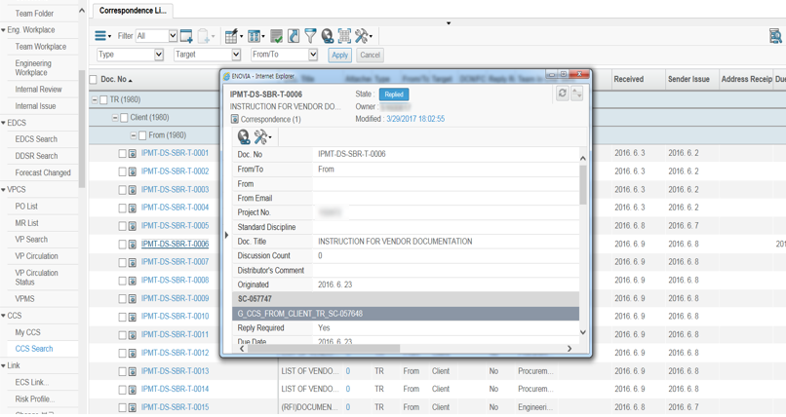
- CCS(Correspondence Control System)

EDCS : Engineering Deliverable Control System
EDCS provides users with capability to manage the status of engineering documents such as drawing, specification, calculation, BM, MR, TBE, procedure and manual. This is a web-based system and stores all necessary data of engineering documents in it and helps engineers to control data and prevents delay of submission. It also provides various kinds of necessary reports.
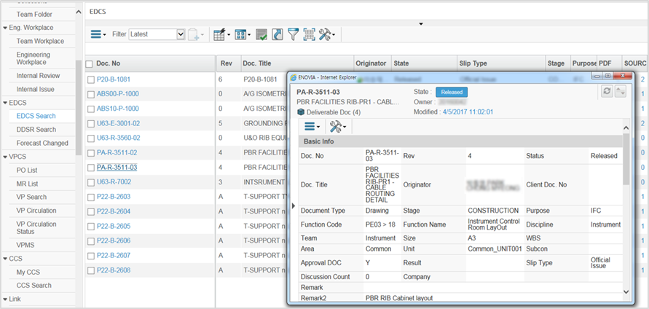
- EDCS(Engineering Deliverable Control System)

VPCS : Vendor Print Control System
VPCS provides users with capability to manage vendor prints acquisition, circulation, reviewing and status monitoring in an efficient and effective manner. Vendor should submit vendor prints via Internet to VPCS and all project members can access vendor prints. After submitting the vendor print, project members can circulate and review the vendor print through VPCS. And vendors can directly access VPCS through Internet to get information about vendor prints review results. Users can generate summary of vendor prints status and review result report.

Vendor print review procedure is totally digitalized. Once a vendor print is received from Vendor and stored in a vendor print folder, then automatic background process of Ensemble+ converts all vendor prints to online comment-able file, which should be distributed to each discipline engineer. They make markup on the digital vendor print and all digital comments should be returned to the responsible engineer in one excel file. This file is returned to the vendor through the project administrator as a result of the review.

In the middle of vendor print review process, all workflows will be monitored and comments made by other member can be referred to reference in real time.

VPCS will be also primarily utilized during Phase 2, following the placement of Purchase Orders (POs), when Vendor Prints and other vendor documentation are received, reviewed, and managed as part of the procurement and detailed engineering processes.
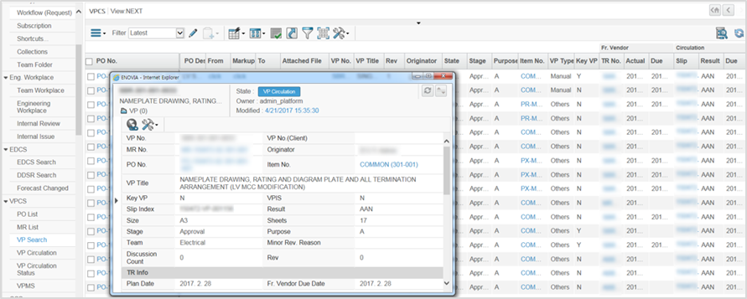
- VPCS(Vendor Print Control System)

Strict version control within Ensemble+ enhances project execution quality by ensuring that all participants work with the most up-to-date documents. The workflow management functionality streamlines business processes and enables effective coordination among project stakeholders. It also facilitates the seamless exchange of transactional information and supports faster responses to changes in engineering status. Administrator defines the roles of various users, access control, level of document security and detail logs of activity at the beginning of project

Progress Reporting
- Progress Planning and Reporting
Progress Planning
Manpower, quantities, production rates and time are inter-related parts of progress and planning that lie beneath all good schedules. Much of the management task to ensure on-time completion is simply to put the necessary resources to work at the right time and place.
The measurement and reporting of actual progress and manpower provide direct feedback to management about the Project status.

Manpower Histogram
Resource planning requires the development of staffing plans and histograms for Project Management, Engineering and Procurement. These staffing plans are based on the scope of work, and the time allowed by the schedule for accomplishing those tasks. The approved budget is used and then forecast work hours needed to accomplish the defined scope of work. The staffing plans and the manpower histograms are based on full- time equivalent (FTE) personnel. This means the total hours worked each period will be divided by the normal straight time hours available for the period to arrive at FTE values.
Staffing histograms updated with actual data for each reporting period, will be issued monthly and will be re-forecasted if there are significant deviations from the original plans. In such cases, recovery efforts need to be developed, agreed and incorporated in the staffing plans.

Phase 1 Progress
Progress (percent complete) will be measured against the total FEED scope using weighted engineering manhours.

Phase 1 progress will encompass all FEED engineering, estimating, project management, and supporting activities required for completion of the Project scope. Progress measurement will be based on the engineering manhour budget established.

The overall Project progress will be calculated by comparing actual expended manhours against the planned manhour budget. Each discipline will be assigned a weighted manhour allocation, and progress will be determined based on the proportion of manhours spent relative to the total budgeted manhours for the respective discipline and activity.

Progress will be consolidated and reported periodically to the responsible discipline leads and project management team. In the event of schedule delays, the responsible discipline lead will develop mitigation measures to recover the schedule, and the Project Manager will review and approve the proposed actions.

The physical progress S-Curve shown below has been prepared based on the preliminary FEED execution plan and planned manhour distribution. As it has been developed during the bidding stage, it is preliminary in nature and intended for reference purposes only. The progress measurement methodology and associated S-Curve may be refined during Project execution as necessary.

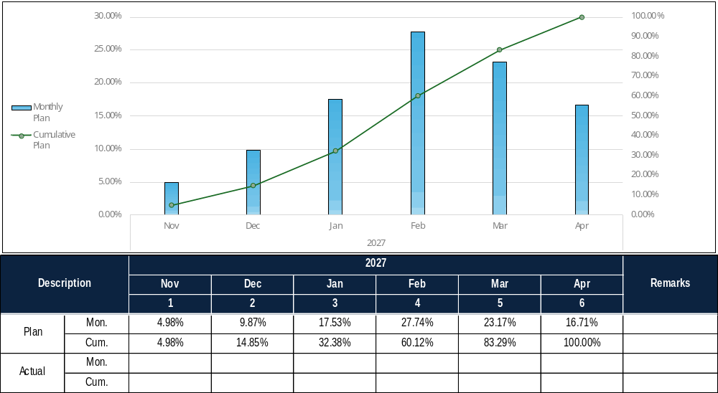
- Physical Progress S-Curve (Preliminary)

Monthly Progress Reports
The Monthly Progress Report will be issued monthly and will be used as systematic basis for recording and presenting Project progress, expenditures and performance.
The uniform format of Monthly Progress Report will be provided. The contents of the reports will include the requirements described in the Contract and will be varied from month to month depending upon the phase of the Project and the items of management focus.
The cut-off date for the Monthly Progress Report will be established and agreed upon at the early stage of Phase 1.

f) Basic and Detail Engineering
Seamless Integration of Engineering between Phase 1 and Phase 2
Seamless integration between engineering work during Phase 1 and Phase 2, with continuity into procurement and construction, will be achieved through a unified execution strategy and aligned work processes across all project phases. The same integrated project team will be maintained from Phase 1 through Phase 2, ensuring continuity of technical knowledge, design intent, and decision-making.
Engineering deliverables developed during Phase 1 stage will be systematically structured and progressively matured to support engineering on Phase 2. Digital tools and common data environments (such as 3D CAD and document management systems) will be consistently utilized to ensure data integrity, version control, and real-time collaboration across disciplines.
Early involvement of procurement and construction teams during Phase 1 will enable alignment on material specifications, vendor strategies and constructability. This approach ensures that engineering outputs are fully aligned with procurement requirements and construction methodologies, minimizing interfaces, reducing risks of changes, and enabling a smooth transition into Phase 2.

Engineering Office Plan
The Project will be executed primarily from the Bidder’s engineering office utilizing the Bidder’s established engineering, project management, and support resources. Engineering, procurement support, cost estimation, and project coordination activities will be performed through an integrated project team to ensure efficient communication, timely decision-making, and effective execution of Phase 1 activities.

Given the limited six (6)-month duration of Phase 1 and the absence of a requirement for permanent Employer presence at the Bidder’s office, the Bidder does not intend to establish a dedicated Task Force Team (TFT). Instead, the Project will be supported by the Bidder’s core engineering and project management personnel, with subject matter experts mobilized as required to support specific technical, commercial, and execution-related matters.

Strategy of 3D Modelling
During Phase 1, the primary objectives of the conceptual 3D model are to support the development of a high-accuracy EPC cost estimate, to review and finalize the locations of equipment, buildings, and pipe racks, and to serve as a tool for facilitating clear discussions with the Employer.

- Strategy
The 3D model serves the OSBL areas outside the OEM-handled ISBL scope and is developed through a conceptual model. The Bidder intends to follow MES-GE-PRO-0004, Ma'aden 3D Model Review Standard as far as practicable; however, detailed requirements and review procedures will be subject to further discussion and agreement during FEED execution.

- Methodology and Tools
The Bidder will utilize proven digital tools and standardized procedures to ensure effective model development and integration:
- Modeling System: SmartPlant 3D (S3D)
- Model Review Tools: Navisworks 2023 (or higher)
- Bidder’s established 3D BIM procedures

- Integration with Procurement and Construction
The 3D model will be actively utilized to support procurement and construction activities during Phase 2, including material take-offs, vendor data integration, and constructability verification. Drawing issuance will be aligned with the overall engineering and construction schedule to support timely execution.
The model will also be made available to the Employer at site during the construction phase, enabling improved visualization, coordination, and decision-making.

Modularization Feasibility Study
In alignment with Employer’s emphasis on modularization in the ITB, the Bidder will review the modular units designed by OEM. Additionally, the Bidder will evaluate the potential application of modularization within the Balance of Plant(BoP) area under the Bidder’s EPC scope. However, it shall be noted that the commitment to "review" modularization does not imply an automatic obligation to "execute" the works as modules. The Bidder will conduct a comprehensive Modularization Feasibility Study during the initial stage to assess the economic viability, schedule impact, and constructability of each potential module. The final decision on modular application will be mutually agreed upon with the Bidder based on the study reports. Furthermore, during the FEED phase, the Bidder will verify the maximum transportable dimensions and weight limits with the Employer. A detailed modularization feasibility review will then be performed based on these confirmed logistics parameters.

List of Engineering Deliverable

The Bidder will endeavor to comply with the requirements of MCIS TK-0382 Minimum Deliverable List to the maximum extent practicable. Detailed deliverable requirements, document lists, and associated conditions are defined in Appendix 9 – Deliverable List.

List of Engineering Software
A comprehensive list of engineering software to be utilized by the Bidder during the engineering stage is provided in the table below.
Software / System | Function | Version
Common
AutoCAD | 2D Drawing Draft | 2023
Process Engineering
MicroStation | P&ID, PFD, UFD, etc. | 10.0
Aspen Plus | Process Steady State Simulation | 15.0
Aspen Dynamics | Process Dynamic Simulation | 15.0
Aspen HYSYS | Process Steady State & Dynamic Simulation | 15.0
AFT IMPULSE | Surge Analysis | 11.0
AVEVA Dynamic Simulation | Process Dynamic Simulation | 2025
AVEVA PRO/II Simulation | Process Steady State Simulation | 2025
ProMax | Process Steady State Simulation | 7.0
Aspen Flare System Analyzer | Flare sizing & Hydraulic Calculation | 15.0
PHA PRO | Process Hazard analysis (HAZOP) | 8
AFT Fathom | Hydraulic Calculation & Simulation for incompressible fluid | 14.0
AFT Arrow | Hydraulic Calculation & Simulation for compressible fluid | 11.0
Static Equipment Engineering
PV ELITE | Mechanical Strength Calculation for Vessel, S&T H/EX. | V.28
COMPRESS | Mechanical Strength Calculation for Vessel, S&T H/EX. | V.8500
ANSYS | Finite Element Analysis | 2026  R1
HTRI Xchanger | Thermal Rating for Heat Exchanger | 9.4
TANK-PRO | Calculation Program of Various Type of Tank | N/A
Piping Engineering
FE/PIPE | Finite Element Modeling with ASME code | 2026
CAESAR Ⅱ | Pipe Stress Analysis | V15
PIPENET | Fire Fighting Pipe Network Analysis | 1.12.0
E20 II | HVAC Load Calculation | 5.11
Smart 3D | 3D Modeling Program | V14
Electrical Engineering
ETAP | Electrical Calculation Program | 24.0.0 or later
RELUX | Lighting Calculation | N/A
Instrument & Control Engineering
Smart Instrumentation | Instrumentation data and design solution | 13.1
Civil Engineering
MIDAS Civil | Structural Analysis and Design | 2018
MIDAS SET/Art | Structural Element Analysis & Design Modula | 3.3.1
Midas Building Package | Structural Analysis and Design | V400
SAP2000 | Structural Analysis and Design | V17
ALLPile | Pile analysis (compression with settlement, uplift, lateral capacity) | V7
HEC-PACK | Hydrology and Hydraulic Modeling Solution
GRL Weap | Dynamic Analysis of Deiven Piles | 2005
SURFER | Contouring and 3D Surface Mapping Program | 8
SLOPE/W | Slope Stability Analysis | V6
SEEP/W | Finite Element Seepage Analysis | V6
SIGMA/W | Finite Element Stress and Deformation Analysis | V6
EXCAV/W | The Design of Earth Retaining Structures Under Ground Excavation
STADD Pro | Structural Analysis and Design | V8i
DYNA5 | Dynamic Foundation Analysis
L-PILE PLUS | Rational Procedures for Analyzing a Pile under Lateral Loading | V5
GROUP | Rational Procedures for Analyzing a Pile under Lateral Loading | 7
SUNEX | Design of Earth Retaining Structures Underground Excavation | 5.73
Civil 3D | Earthwork | 2023
PEDAS Foundation | Structural Analysis and Design | 2016
TEKLA STRUCTURES | 3D modeling | 2025
Architecture & Structure Engineering
STAAD Pro | Structural Analysis & Design | 25.00.01.424
MIDAS Gen | Structural Analysis & Design | 2025
MIDAS SDS | Plate element analysis module for Slab & Mat foundation design. | 2025
MIDAS Set | Structural Element Analysis & Design Module | 2025
MIDAS Design+ | Structural Element Analysis & Design Module | 2025
TEKLA STRUCTURES | 3D modeling for structure and building | 2025
General Information Productivity
MS Office | Word processing | MS 365
MS Excel | Spreadsheets | MS 365
MS PowerPoint | Presentation | MS 365
Bluebeam Revu | PDF Tool | 20
PDF-XChange Editor | PDF Tool | 8.0
MS Outlook | E-mail
MS Teams | Collaboration (Conference Call)

g) Procurement, Subcontracts and Construction
To be developed later on during Phase 1

h) Training, Commissioning, Start‐up and Handover
To be developed later on during Phase 1

i) Health, Safety and Environmental
HSE Philosophy and Objectives
The Bidder will implement a proactive Health, Safety, and Environmental (HSE) management approach throughout the Phase 1, with a strong emphasis on “Safety by Design.” The objective is to identify, eliminate, or reduce risks at an early stage, thereby minimizing potential impacts during construction and operation and reducing reliance on procedural controls in later phases.

HSE Management Framework
A project-specific HSE Management Plan will be developed during Phase 2, EPC stage, aligned with international best practices and applicable Saudi Arabian environmental regulations and standards. The plan will be structured to ensure continuity between engineering and construction phases, enabling a seamless transfer of HSE requirements into Phase 2 execution.

Risk Assessment and HSE Reviews

During Phase 1, Preliminary HAZOP (the Hazard study specified for Stage 3) will be conducted through a workshop at the Bidder’s headquarters in Seoul, with the Employer participating. The workshop will cover the BoP, excluding vendor packages. Vendor packages will be reviewed during Phase 2 when the required vendor information is available.

SIL Assessment (Determination) will be performed immediately following the Preliminary HAZOP workshop for SIFs identified during the HAZOP workshop. A Safety Requirements Specification (SRS) covering the general requirements will be developed, and the SIF-specific requirements will be incorporated during Phase 2. SIL Verification will be conducted during Phase 2, when the required vendor data (e.g., failure rates) are expected to be available.

Quantitative Risk Assessment (QRA) will be performed during Phase 1 to evaluate the risks associated with major accident scenarios, including toxic and flammable gas dispersion, fires, and explosions, and to determine whether risk reduction measures are required to ensure that the risks are within acceptable limit.

Loss Prevention and Environmental Design
Loss prevention principles will be embedded into the design process to enhance overall safety and operability. Key considerations include:

- Layout optimization and safe spacing
- Access and egress for operation and maintenance
- Fire and explosion risk mitigation
- Drainage and spill containment systems
- Constructability and safe installation

Environmental aspects, including water management, dust control, and waste handling, will be incorporated into the design basis in compliance with Saudi Arabian regulatory requirements.

Transition to Construction Phase
While detailed construction HSE procedures will be further developed during Phase 2, the engineering phase will establish a robust foundation for safe execution. Design outputs will incorporate constructability and safety considerations to ensure that construction and commissioning activities can be carried out efficiently and with minimized risk.

j) Quality Control and Quality Assurance
This section is addressed in T12. Quality Assurance. Please refer to that section for further details.

THIS APPENDIX FORMS PART OF THE BID
SUBMITTED BY
WORKS: EPC CONTRACT FOR MM Cluster PROJECT, KSA
RFP NO.: CPP-ITB-PD&E-26-101 | DATE: ………………….……28 Oct.2026……………………….
SIGNATORY OF BIDDER | …………………Yong Kim………………………..………..………….

- Technical Data
To be developed later on during Phase 1

THIS APPENDIX FORMS PART OF THE BID
SUBMITTED BY
WORKS: EPC CONTRACT FOR MM Cluster PROJECT, KSA
RFP NO.: CPP-ITB-PD&E-26-101 | DATE: ………………….……28 Oct.2026……………………….
SIGNATORY OF BIDDER | …………………Yong Kim………………………..………..………….

- Bidder’s Schedule
The Bidder’s proposed schedules presented below are preliminary and subject to adjustment during execution stage, in accordance with the OEM detailed schedules.
Please refer to the Appendix 1 – FEED Schedule (Preliminary) for further details.

Table G-1 - General Information
Combination of Milestones and Key Milestones
Milestone No. | Milestone Type | Description | Time for Completion  (Months)
1 | Milestone | EPC Stage 1 “FEED” award | 0
2 | Milestone | Kick-off Meeting | 0.5
3 | Milestone | Organization Chart | 1
4 | Milestone | OEM Vendor information Lot 1 (From OEM) | 1.25
5 | Milestone | Engineering Deliverable List | 1.25
6 | Milestone | Plot Plan Freeze | 2.75
7 | Milestone | P&ID issue for Review | 3
8 | Milestone | HAZOP Review Complete | 3.75
9 | Milestone | FEED Final Estimate issued (Class 3 AACE) | 4.5
10 | Milestone | 30% Engineering 3D Model Reviews Complete | 4.5
11 | Milestone | Execution Plan Including Level 3 Schedule | 4.5
12 | Milestone | FEED Completion - LSTK EPC Estimate | 6

Table G-2 – Milestones
Project planning Milestones
Milestone No. | Description | Time for Completion  (Months)
1 | EPC Stage 1 “FEED” award | 0
2 | Process Design Basis / Criteria - IFR | 1.5
3 | Equipment List - IFR | 2
4 | UFD - IFR | 2.5
5 | P&ID - IFR | 3
6 | Piping Material Class Specification / Line Class Index - IFA | 4
7 | Electrical Equipment Arrangement Plans / Layouts – IFA | 5
8 | Architectural FEED Drawings - IFF | 6
9 | FEED Completion | 6

Table G-3 - Contractor Key Milestones (Clauses 8.2 & 8.7 of Conditions of Contract)
This Key Milestone is made based on the Bidder’s Preliminary EPC Schedule. Achievement of the Key Milestones is dependent upon the timely completion of OEM engineering deliverables and Employer-led early activities as identified in the Preliminary EPC Schedule submitted by the Bidder.
Milestone No. | Description | Time for Completion  (Months)
1 | Mechanical Completion | 32
2 | First Gold Production | 34

THIS APPENDIX FORMS PART OF THE BID
SUBMITTED BY
WORKS: EPC CONTRACT FOR MM Cluster PROJECT, KSA
RFP NO.: CPP-ITB-PD&E-26-101 | DATE: ………………….……28 Oct.2026……………………….
SIGNATORY OF BIDDER | …………………Yong Kim………………………..………..………….
- Organization / Key Personnel
This section is addressed in 2.2 b) Organization / Key Personnel of T2. Description of the Work Plan. Please refer to that section for further details.

THIS APPENDIX FORMS PART OF THE BID
SUBMITTED BY
WORKS: EPC CONTRACT FOR MM Cluster PROJECT, KSA
RFP NO.: CPP-ITB-PD&E-26-101 | DATE: ………………….……28 Oct.2026……………………….
SIGNATORY OF BIDDER | …………………Yong Kim………………………..………..………….

- Proposed Subcontractors and Suppliers

Construction Contractor
Gulf Asia Contracting Co., LLC. (General Construction Contractor)

Supplier
To be developed later on during Phase 1

THIS APPENDIX FORMS PART OF THE BID
SUBMITTED BY
WORKS: EPC CONTRACT FOR MM Cluster PROJECT, KSA
RFP NO.: CPP-ITB-PD&E-26-101 | DATE: ………………….……28 Oct.2026……………………….
SIGNATORY OF BIDDER | …………………Yong Kim………………………..………..………….

- Bidder Experience

Similar Experience over the last 5 years (Soft Work)
Project Title | Location | Owner | Description | Scope of Work | Contract Value  (USD Mil.) | Contract Period
DL Chemical Solution POE Project | Korea | DL Chemical | Solution POE: 100,000 MTY | Basic Engineering | 10 | Nov. 2025  Mar. 2026
DL Chemical HT-PB  Extended BDP | Korea | DL Chemical | HT-PB: 10,000 MTA | Basic Engineering | 1.6 | July. 2023  Nov. 2023
LG Chemical Demeter (PLA) FEED Project | USA | LG Chem. | Polylactic Acid: 75,000 MTA | FEED | 6 | May. 2023  Jan. 2024
NRZ Fertilizer FEED Project | Australia | NeuRizer | Ammonia: 560KTA  Urea: 1 MTPA | F/S, FEED | 31 | Aug. 2021  Dec. 2023
AN & MCN FEED Project | Malaysia | Pengerang Intermediate Chemical & Asahi Kasei | Acrylo Nitrile: 266,000 MTY  MCN(Acetonitrile) : 5,000 MTA | FEED | 6 | Jun. 2022  Dec. 2022
Cariflex Asia Expansion Phase I Project | Singapore | Cariflex Pte. Ltd. | IR Latex : 15,400 MTY | Conceptual Design | 1 | Mar. 2021  Jun. 2021
DL Chemical Catalyst BE | Korea | DL Chemical | Catalyst: 330 TPY | Basic Engineering | 2 | Feb. 2022  Jun. 2022
GTPP (Golden Triangle Polymer Project) | USA | CPChem | HDPE: 1,000,000 MTY x 2 | FEED | 20 | Mar. 2019  Jun. 2020
Ras Laffan Petrochemical Project | Qatar | Qatar Petroleum(QP) + CPChem | 1.68 MTPA PE  (1 MTPA ASL + 0.68 MTPA ADL)  OSBL | FEED | 13 | Dec. 2019  Jun. 2021
Formosa Sunshine Project | USA | Formosa(FG LA LLC) | PP: 600,000 MTA | FEED  (Supervision) | 1 | Jul. 2019  Feb. 2020
Amiral PB Project | Korea | Daelim Industrial Co., Ltd. | PB: 800,000 MTY | FEED | 3 | Jan. 2019  Nov. 2019
Lotte BP C-Project | Korea | Lotte BP Chemical | CO Plant revamping  POX Unit  Syngas adjustment system (membrane)  H3 Purification | FEED | 2 | Dec. 2019  Jun. 2020
Heavy Feed Petrochemical Complex (HPC) Project | Korea | Hyundai Chemical | Ethylene: 821,000 MTY  Propylene: 416,000 MTY  LDPE: 300,000 MTY  HDPE: 2 x 250,000 MTY  PP: 2 x 250,000 MTY  BDU: 145,000 MTY | FEED  (All Complex) | 12 | Nov. 2018  Mar. 2020

Petrochemical EPC Experience over the past 7 years (EPC)
Project Title | Location | Owner | Description | Scope of Work | Contract Value  (USD Mil.) | Contract Period
APAO Project | Korea | D-REX Polymer  (DL Chemical + REXtac) | Amorphous Poly Alpha Olefin: 40,000 MTY | EPC | 102 | Jun.2021  Dec.2022
APAO Utility Project | Korea | DL Chemical | Amorphous Poly Alpha Olefin: 40,000 MTY Utility Facility | EPC | 13 | Jun. 2021  Dec. 2022
NBL Project | Malaysia | LG Petronas Chemicals Malaysia | NBR(Nitrile Butadiene Rubber) Latex : 200,000 MTY (Liquid Base) | EPC | 135 | Mar. 2021  Feb. 2023
GTPP (Golden Triangle Polymer Project) | USA | CPChem | HDPE: 1,000,000 MTY x 2 | EPC | 500 | Jul. 2022  Dec. 2025
Ma’aden Ammonia 3 Project | Saudi Arabia | Ma’aden | Ammonia: 1,100,000 MTY | EPC | 892 | Nov. 2018  Jun. 2022
Heavy Feed Petrochemical Complex (HPC) Project | Korea | Hyundai Chemical | Ethylene: 821,000 MTY  Propylene: 416,000 MTY  LDPE: 300,000 MTY  HDPE: 2 x 250,000 MTY  PP: 2 x 250,000 MTY  BDU: 145,000 MTY | EPC | 530 | Apr. 2019  May 2021
YNCC No.2 NCC Revamping Project | Korea | YNCC | NCC: 580 KTA → 915 KTA (335 KTA Revamping)  BD: 130 KTA | EPC | 272 | Jun. 2019  Jun. 2021
LG No.2 Complex L Project | Korea | LG Chemical | LLDPE & HDPE:  600 KTA(300 KTA x 2 Trains) | EPC | 101 | Dec. 2018  Jul. 2021
Daelim mPE Project | Korea | Daelim Industrial Co., Ltd. | mPE: 410,000 MTY | EPC | 171 | Nov. 2018  Oct. 2020
Daelim EPO Revamping Project | Korea | Daelim Industrial Co., Ltd. | EPO: 1,000 MTA → 5,000 MTA | EPC | 30 | Jun. 2018  Oct. 2019
H-NC3 Project | Korea | Lotte Chemical | Ethylene: 1,030 KTA to 1,230 KTA | EPC | 150 | Apr. 2017  Dec. 2018

THIS APPENDIX FORMS PART OF THE BID
SUBMITTED BY
WORKS: EPC CONTRACT FOR MM Cluster PROJECT, KSA
RFP NO.: CPP-ITB-PD&E-26-101 | DATE: ………………….……28 Oct.2026……………………….
SIGNATORY OF BIDDER | …………………Yong Kim………………………..………..………….

- Technical Alternatives
Strike-through to delete the reference A or B that does not apply.
Option A ‐ We hereby confirm that we fully comply with all scope and technical requirements of the RFP Documents and specifically technical specifications.
Option B ‐ We hereby list below alternative or exceptions to the scope and/or technical requirements of the RFP Documents, and have listed these below. Other than those listed, we fully comply with all other conditions RFP Document requirements. The details are specified in T15. Assumptions and Exclusions in this Technical Proposal.

THIS APPENDIX FORMS PART OF THE BID
SUBMITTED BY
WORKS: EPC CONTRACT FOR MM Cluster PROJECT, KSA
RFP NO.: CPP-ITB-PD&E-26-101 | DATE: ………………….……28 Oct.2026……………………….
SIGNATORY OF BIDDER | …………………Yong Kim………………………..………..………….

- Acceptance of Conditions of Contract
The Bidder acknowledges the Conditions of Contract included in the ITB. However, the Bidder notes that certain clauses of the draft Contract require amendments to appropriately reflect the scope, duration, and nature of the Engineering Consultancy Services under the Contract. Accordingly, the Bidder has proposed certain amendments to the Conditions of Contract to ensure alignment with the Project requirements and the Bidder's proposed execution arrangements.
Please refer to Section C5 – Commercial Alternatives of the Bidder’s Commercial Proposal for further details.
THIS APPENDIX FORMS PART OF THE BID
SUBMITTED BY
WORKS: EPC CONTRACT FOR MM Cluster PROJECT, KSA
RFP NO.: CPP-ITB-PD&E-26-101 | DATE: ………………….……28 Oct.2026……………………….
SIGNATORY OF BIDDER | …………………Yong Kim………………………..………..………….

- Local Content and Saudization
To be developed later on during Phase 1
THIS APPENDIX FORMS PART OF THE BID
SUBMITTED BY
WORKS: EPC CONTRACT FOR MM Cluster PROJECT, KSA
RFP NO.: CPP-ITB-PD&E-26-101 | DATE: ………………….……28 Oct.2026……………………….
SIGNATORY OF BIDDER | …………………Yong Kim………………………..………..………….

- Safety Record
To be developed later on during Phase 1

THIS APPENDIX FORMS PART OF THE BID
SUBMITTED BY
WORKS: EPC CONTRACT FOR MM Cluster PROJECT, KSA
RFP NO.: CPP-ITB-PD&E-26-101 | DATE: ………………….……28 Oct.2026……………………….
SIGNATORY OF BIDDER | …………………Yong Kim………………………..………..………….

- Quality Assurance

QA/QC Plan
Please refer to the Appendix 2 – QA.QC Plan (Preliminary).

Quality Management Manual
Please refer to the Appendix 3 – Quality Management Manual and Appendix 4 - Quality Process List.

ISO 9001 Certificate
Please refer to the Appendix 5 – ISO 9001 Certificate.

Quality Organization Chart
The Bidder’s Quality Organization is as shown below.
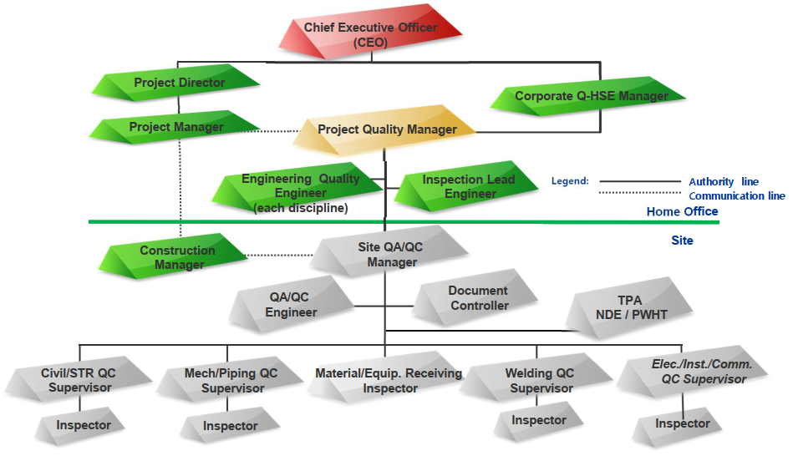
THIS APPENDIX FORMS PART OF THE BID
SUBMITTED BY
WORKS: EPC CONTRACT FOR MM Cluster PROJECT, KSA
RFP NO.: CPP-ITB-PD&E-26-101 | DATE: ………………….……28 Oct.2026……………………….
SIGNATORY OF BIDDER | …………………Yong Kim………………………..………..………….
- Quality Organization Chart

- Summary of Bidders Manhours
The following information is for Bid evaluation purposes only, and will not form part of the Contract.
REF No. | Item Description | Total Man hours
1 | Project Management
1.1 | Project Management
 | Sub Total
2 | Engineering
2.1 | Process
2.2 | Environment
2.3 | Rotating Equipment
2.4 | Static Equipment
2.5 | Piping
2.6 | Fire Protection
2.7 | HVAC
2.8 | Electrical
2.9 | Instrument & Control
2.10 | Civil
2.11 | Architecture and Structure
2.12 | Design Safety
2.13 | Module
2.14 | Comm.& Start-up, Lab. Material etc.
 | Sub Total
3 | Procurement
3.1 | Procurement Coordination | Included in Item 1
3.2 | Logistics | Included in Item 1
 | Sub Total | -
4 | Construction Management
4.1 | Construction Management | Included in Item 1
 | Sub Total | -
Total
THIS APPENDIX FORMS PART OF THE BID
SUBMITTED BY
WORKS: EPC CONTRACT FOR MM Cluster PROJECT, KSA
RFP NO.: CPP-ITB-PD&E-26-101 | DATE: ………………….……28 Oct.2026……………………….
SIGNATORY OF BIDDER | …………………Yong Kim………………………..………..………….

- Unpriced Estimated Construction Quantities
To be developed later on during Phase 1

THIS APPENDIX FORMS PART OF THE BID
SUBMITTED BY
WORKS: EPC CONTRACT FOR MM Cluster PROJECT, KSA
RFP NO.: CPP-ITB-PD&E-26-101 | DATE: ………………….……28 Oct.2026……………………….
SIGNATORY OF BIDDER | …………………Yong Kim………………………..………..………….

- Assumptions and Exclusions
The Bidder’s proposal basis and exceptions have been summarized in the following table in the form of key assumptions and exclusions.
The assumptions define the basis and conditions under which the proposal has been developed, while the exclusions identify items that are not included in the Bidder’s scope of work and its bid price.
No. | Discipline | Assumptions | Exclusions
1 | Common | - S3D will be used for 3D modelling.  - All MMGP As-built documents (including calculations, equipment load data, RFQs, MTO, 3D models, etc.) shall be provided in editable native file formats immediately upon Contract Award to support the re-use design strategy and accelerated Project execution.  - The MMGP As-built documents and MMGP/Ma'aden specifications shall be adopted as the project baseline documents. | - 154 km raw water pipeline from Ar Rjum, including booster stations  - Relocation and/or demolition of existing facilities (e.g., Solar PV panels)  - Mining facilities in Area 2000, permanent village, provisions for future expansion and other external infrastructure facilities located outside the plant battery limits
2 | Process | - OEM shall issue a Utility Summary and Reagent/Chemical Consumption Summary at a minimum 90% accuracy level at project commencement (Kick-Off), to serve as the firm design basis for BoP. Late or incomplete issuance will impact on the Bidder’s proposed schedule.  - To achieve the overall schedule through Phase 2, P&ID development will commence during Phase 1 and the first issue will be at the beginning period of Phase 2.  - The Equipment, Instrument, Line Numbering Procedure will follow the MMGP Project basis.  - The bid is based on the Employer providing the editable Equipment Data Sheet format during Phase 1. | - N/A
3 | Environment | - As-built documents of the existing MM Project related to site drainage and wastewater treatment facilities, and the latest English versions of applicable environmental regulations, environmental design guidelines, and ESIA approval conditions issued by MEWA, NCEC, and other relevant authorities, to be provided by the Employer immediately upon Contract Award. | - N/A
4 | Rotating/Static  Equipment | - The project specifications for BoP equipment procurement shall be prepared using the specifications provided by the Employer as-is and shall be submitted accordingly. | - N/A
6 | Piping | - Interface points between OSBL and ISBL are based on edge of common piperack for process area. (Piping connecting between process units, including piperack, shall not be considered.) | - N/A
7 | Fire Protection | - It is based on receiving SAIS approved Stage 1 Fire Protection System FEED Package specified in Annex A Part 4 Section 5.4.4. | - N/A
8 | Electrical | - Separate Electrical Design Basis, Telecommunication/Security Design Basis, and Specifications will not be developed for the MMC Gold Project during Phase 1 and are excluded from the Phase 1 scope and cost estimate.  - Any project-specific deviations, waivers, modifications, or updates shall be documented in a dedicated register and submitted as supporting documentation for the cost estimate.  - No new Solar Power System or Energy Storage System (ESS) has been considered for the MMC Gold Project. Furthermore, no interface with the existing MMGP Solar Power System or Energy Storage System has been considered.  - Power for MMC Gold Project electrical loads shall be supplied from the new substations installed as part of the MMC Gold Project.  - PMS (Power Management System) shall be provided as a dedicated system for the MMC Gold Project. No interface with the existing MMGP PMS has been considered.  - No interface with the SEC power supply  - No power supply interconnections from the existing MMGP | - Although the preparation of an RFP for the appointment of the Employer's Site Security Services EPC Contractor is identified as part of the Contractor's responsibilities, this activity has not been included in the Phase 1 scope.  The Bid is based on the assumption that the RFP preparation will be performed during Phase 2 and is therefore excluded from the Phase 1 scope and cost estimate.  - 3D Modeling for the Electrical System has not been considered during Phase 1.  The Bid is based on the assumption that any Electrical 3D Modeling activities will be performed during Phase 2.  - Develop and issue for the following Security Reports have not been considered within the Phase 1 scope.  * Security lighting calculation  * Security camera field of view calculation  * Security system electrical load calculation  - Power System Analysis has not been considered during Phase 1.  The Phase 1 FEED design and material take-off for the Power System shall be based on the existing MMGP design information, equipment data, and quantities.  Any project-specific Power System Analysis and incorporation of MMC Gold Project shall be performed during Phase 2.  - SmartPlant Electrical (SPEL) activities have not been considered during Phase 1.  The Bid is based on the assumption that SmartPlant Electrical will be implemented during Phase 2.  - Review meetings for the Electrical Hazardous Area Classification shall be conducted during Phase 2. Accordingly, these activities have not been considered in the Phase 1 scope.
9 | Instrument & Control | - Based on the same architecture as the existing plant, the baseline design considers a new Control Room and an adjacent Instrument Rack Room to house the Server and Network Cabinets. Meanwhile, PLCs and Remote Marshalling Panels are planned to be installed within the Substation without separate room segregation  - In accordance with the R&R Matrix, the engineering and supply of PCS hardware and software for ISBL fall under the OEM's scope of work, whereas the Contractor shall perform the works for OSBL and the integration between ISBL and OSBL only  - Engineering and procurement for Fire and Gas (F&G) detectors for both ISBL and OSBL have been considered within the Bidder’s scope of work.  - The interface with the existing plant is based on the integration of the PCS and the Fire Alarm System, and only the interface with the existing Control Room is considered within this scope.  - The existing plant specifications shall be applied as the project specifications; any deviations or alternative proposals will be clarified separately and formally issued via an addendum | - Documents required to be submitted in Smart Plant Instrumentation (SPI) format are excluded from the Phase 1 scope and are scheduled for submission during Phase 2 execution.  - The Contractor’s system supply scope is limited to the Operational Technology (OT) network up to Level 3.5 (DMZ). Furthermore, Advanced Process Control (APC) systems, including MES and OTS, shall be considered under the Employer’s scope of work.  - Development and issue for the following Cyber Security Reports (OT) have not been considered within the Phase 1 scope.
10 | Architectural & Structural | - ISBL engineering and AACE Class 3 cost-estimating inputs developed by the nominated OEM will be reviewed and incorporated, as applicable, into the architectural and structural quantity development for the subsequent LSTK EPC estimate development during Phase 1. | - N/A

THIS APPENDIX FORMS PART OF THE BID
SUBMITTED BY
WORKS: EPC CONTRACT FOR MM Cluster PROJECT, KSA
RFP NO.: CPP-ITB-PD&E-26-101 | DATE: ………………….……28 Oct.2026……………………….
SIGNATORY OF BIDDER | …………………Yong Kim………………………..………..………….

Appendices

Appendix 1 – FEED Schedule (Preliminary)

Appendix 2 – QA/QC Plan

Appendix 3 – Quality Management Manual

Appendix 4 – Quality Procedure List

Appendix 5 – ISO 9001 Certificate

Appendix 6 – CVs of Key Personnel

Appendix 7 – Pre-Bid Clarifications for Technical and Commercial

Appendix 8 – Post-Bid Clarifications

Appendix 9 – Deliverable List

